Task :05 30-06-2026

Sub:AWS LOGIN AND LAUNCH AN INSTANCE

1)Create and login into account


2) Search EC2 on the search bar and click on it
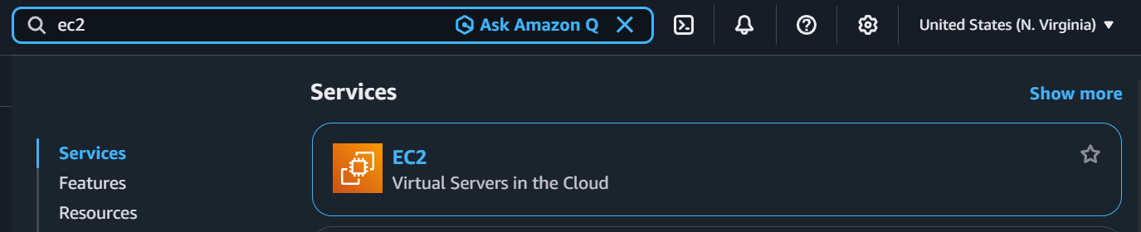

3) Click on the Instance
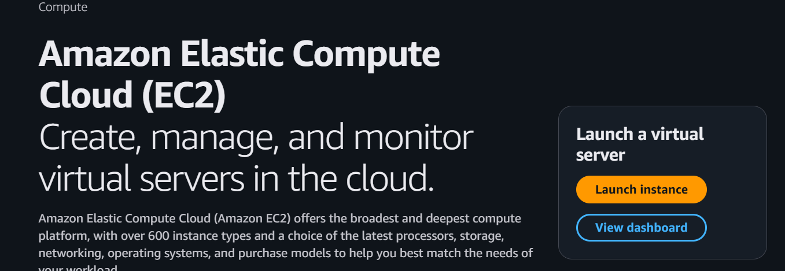

4) click on the launch instance and click on the get started and it will like this
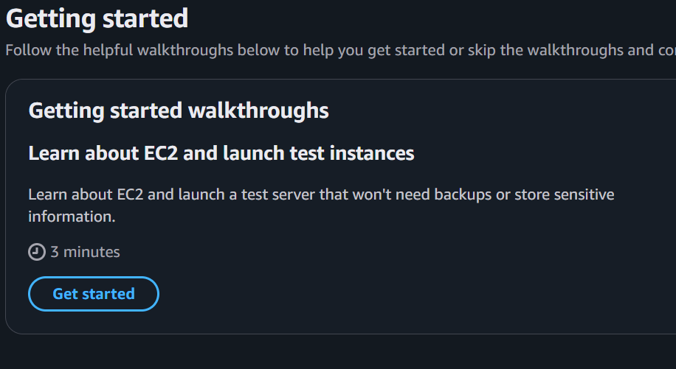

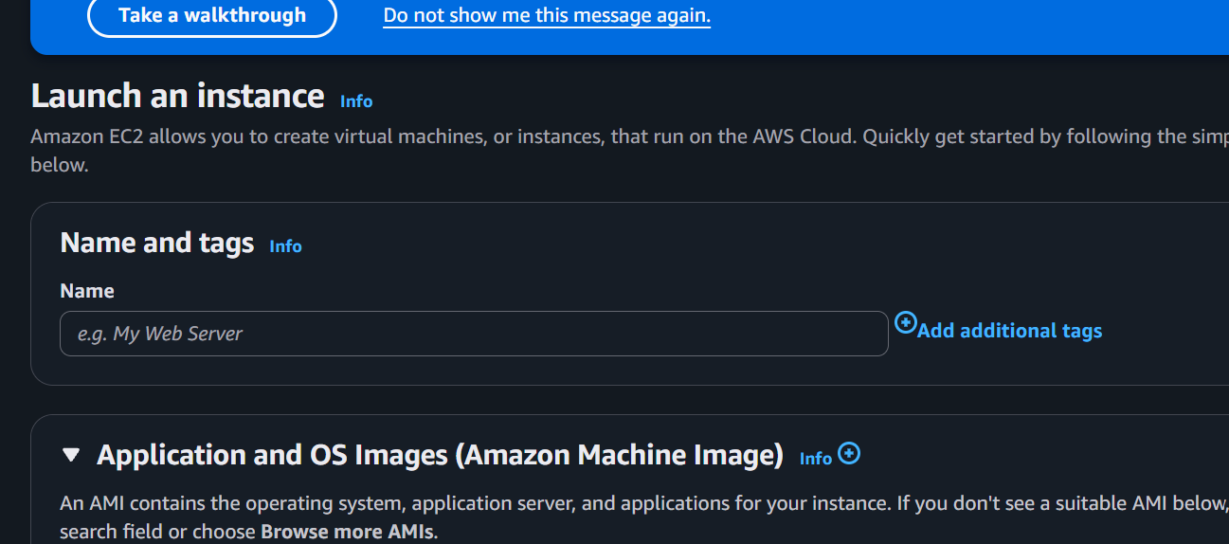
Create it server
Name was karthik

Instance type
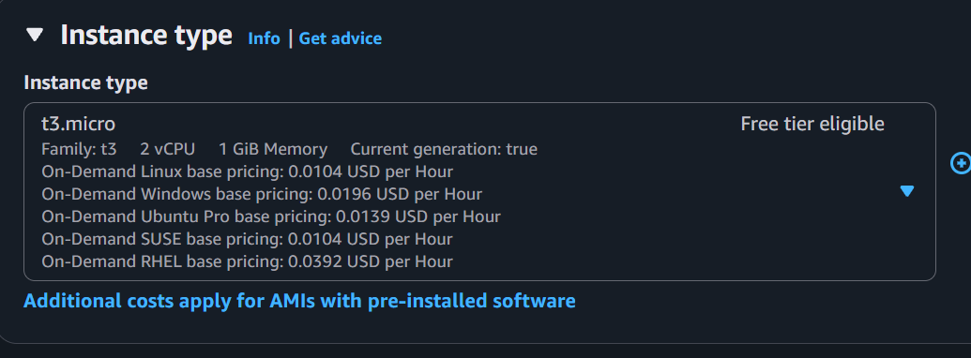

Key pair name
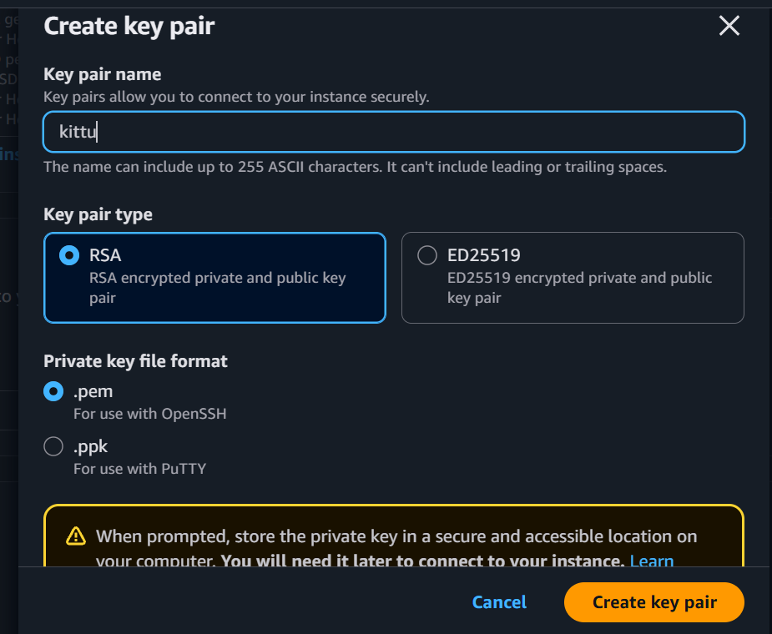
Launch the Instance
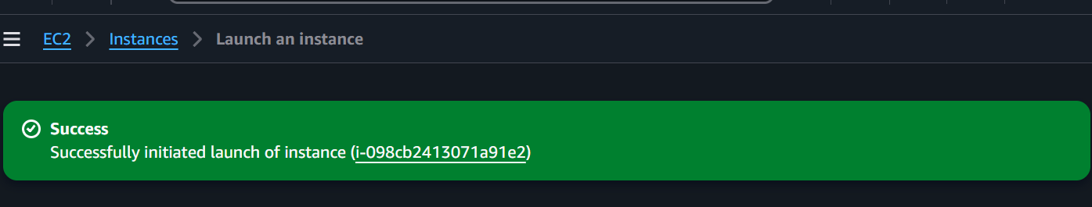
Click on th connect
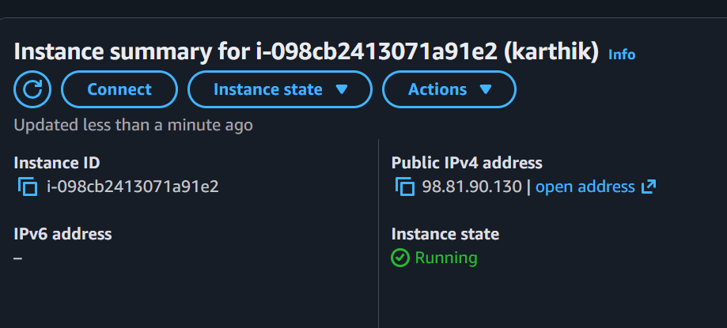

Click on the connect option and click ssh client
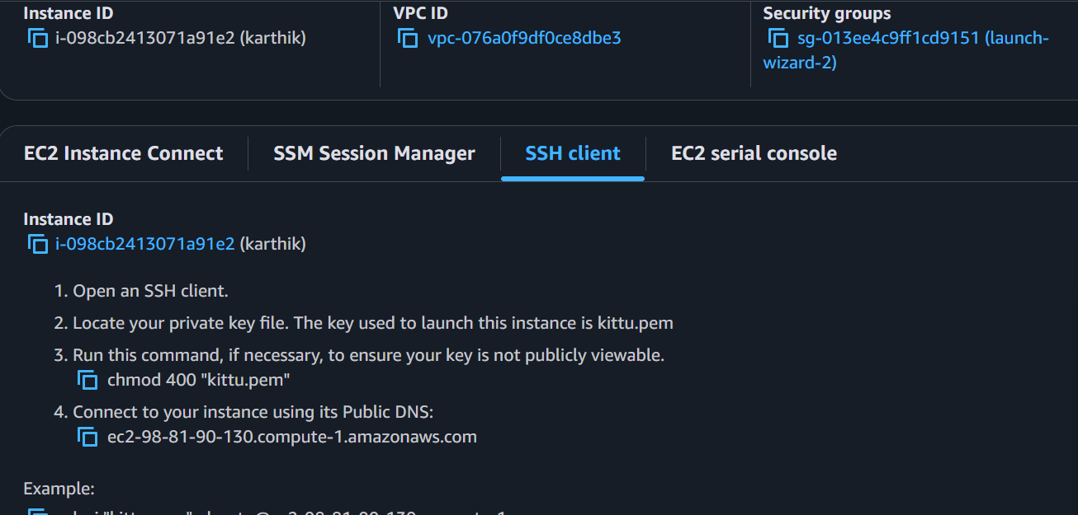
Copy the example one
5)Open the terminal
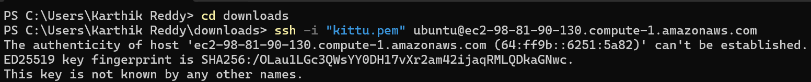
Enter the yes it will connect to the server
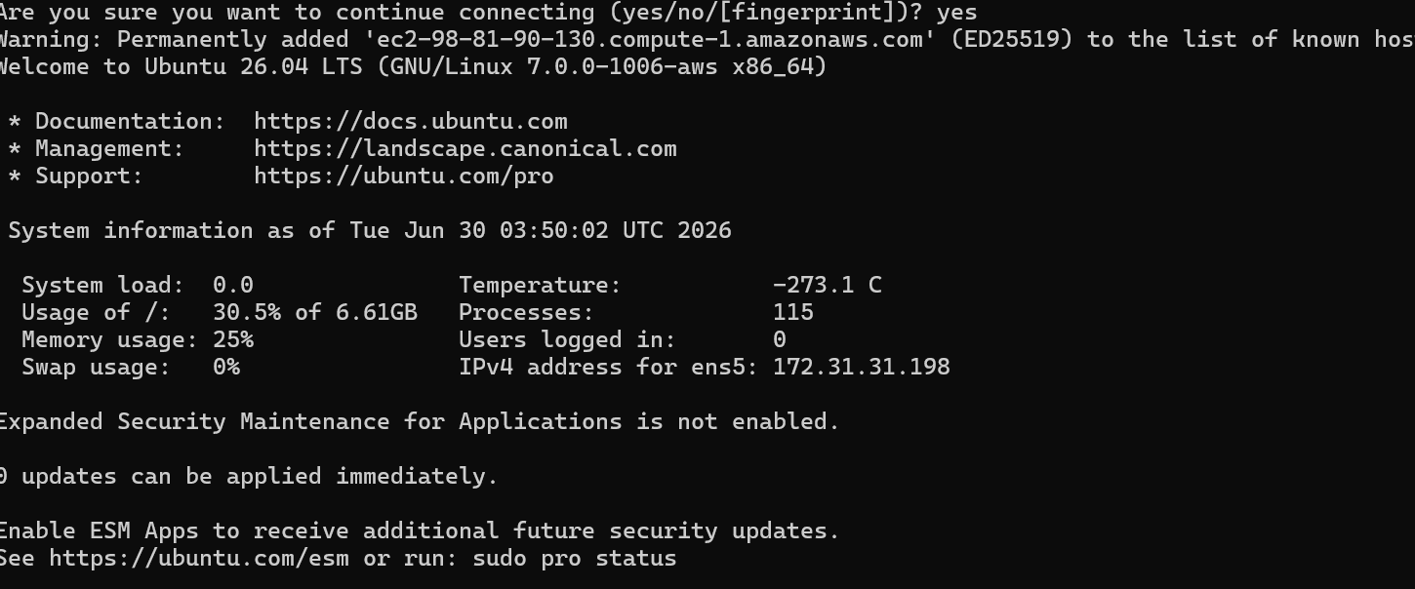
Want to see the ip address
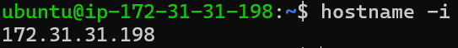

What is Cloud Computing?

Using servers, storage, software, and databases through the Internet.

Why Do We Use Cloud?
● Access data from anywhere.
● Save storage on your device.
● Backup data safely.
● Share files easily.
● Run websites and applications

Deployment Models:
The deployment models used for Where the cloud is used
Public Cloud:
Anyone can use it.
Example: You save your files in Google Drive.
Private Cloud:
Only one company can use it.
Example: A bank stores customer data.
Hybrid Cloud:
Uses both public and private cloud.
Example: A hospital stores patient records privately but hosts its website on AWS.
Community Cloud:
Shared by similar organizations.
Example: Several colleges share one cloud.

Service Models:
The service models are used for What the cloud provides
IaaS (Infrastructure as a Service):
Gives you servers to create your own system.
Example: AWS EC2 – You create and manage your own server.
PaaS (Platform as a Service):
Gives you a platform to write and run your code.
Example: Google App Engine – You write code, and it runs it for you.
SaaS (Software as a Service):
Gives you ready-to-use software.
Example: Gmail – Just open it and use it; no installation needed.

